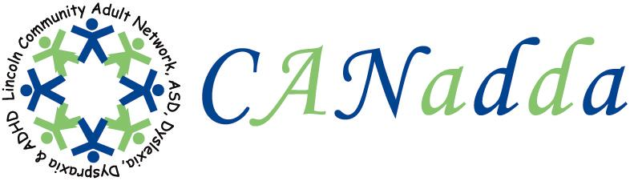
Newsletter December 2009 Issue 4

Tel: 01522 880922

Web Site: www.canadda.org.uk

Chairperson Mrs Debbie Marshall Secretary Mrs Hayley Allison

Email debbie.canadda@yahoo.co.uk Email hayleymarieallison@hotmail.co.uk
Chair of CANadda

Debbie Marshall

Geoff Garner gave an interesting talk on sexuality at last month’s support meeting. Thank you Geoff for being open and honest.

I had a very busy November, it’s been all go for CANadda. Hayley Allison and I attended our first autism conference on behalf of CANadda.

CANadda’s first leaflets have been printed. You can obtain one either from one of CANadda’s support meetings, or you can pick one up from any one of Lincolnshire Co-operative’s Pharmacies.

Our Christmas Party is on the 21st of December, we are having a light buffet, there will be games set up, and some Christmas background music. Everyone is welcome, including children. I hope to see you there.

On behalf of the committee I would like to wish everyone a very
MERRY CHRISTMAS AND A HAPPY NEW YEAR.



Meeting Dates

21st December – Xmas Party ( No Alcohol)
18th January – Open Discussion
15th February - Stress Managememt

Washingborough Methodist Church
Lincoln Rd, Washingborough,

LN4 1AT

7:30pm – 9:30pm

Boogie Nights

Boogie Nights Saturday 5th December at 6pm at Lincoln Drill Hall, Box Office Tel: 01522 873894. It’s £2.00 per person. This is a safe haven of music and dance especially for over 16’s with disabilities. It’s also for their friends, families and carers. There is a separate quiet part if anyone finds the noise of the music too much and at 8pm you are welcome to stay on to Stayin’ Alive.

Antony Costa

Antony, with his family, was on Family Fortunes on Sunday 26th November. Antony used to be in a boy band called Blue. If you missed it, Antony’s chosen charity was the National Autistic Society. They won and went through to play big money and Costa won the jackpot of £30,000. Antony said he has a younger cousin, who is autistic.

BAD WEATHER

Always check before attending a support meeting when there is bad weather, as the support meeting may have been cancelled.
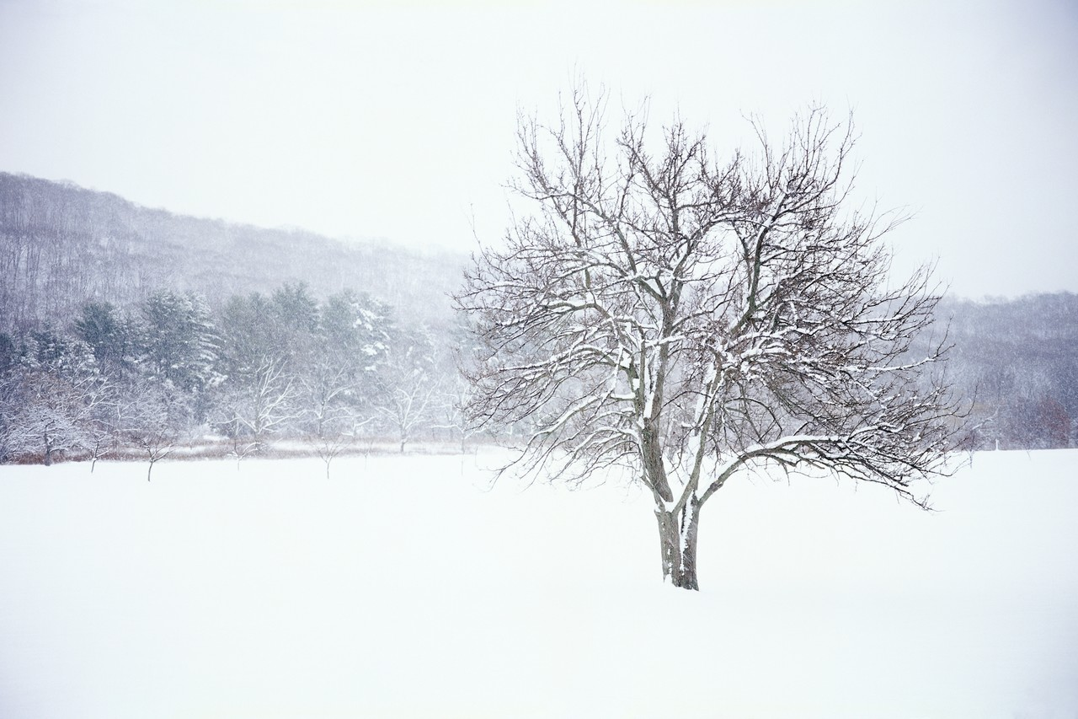

A Special Thank You To

David Harris for his kind donation who keeps supporting CANadda and believing in me, and Paul Roberts of the Lincoln Autistic Society for the DVD for CANadda’s library. It’s much appreciated.

Bowling

We had our first bowling event at Washingborough on Wednesday 11th November. For more details and pictures, please go to CANadda’s website: www.canadda.org.uk

CV’s

If you would like the chance to get some advice on your CV, please see one of the committee members.

Quote

“ I was in Special Ed classes from the time I flunked the second grade. It didn’t help my self-esteem growing up with the stigma of being “Learning Handicapped”. Even though deep inside I knew I was smart, I just couldn’t prove it through the “normal” channels of testing the way other kids could.

When I learned in my 7th grade Special Ed class that Albert Einstein was dyslexic, I stopped being ashamed
of my disability. It gave me a sense of pride I had never experienced before. I didn’t know exactly what Albert Einstein had done; I just knew that the same people who made me feel inferior thought he was a “genius”. Back then, I was never thought of as a genius, but because Einstein and I had something in common, I realized I had potential to do great things. Just knowing that lit the candle within me, and it was a turning point in my life. This website is dedicated to helping others find their way on that road to self discovery, with hopes that they might find who they are sooner”.

Stacy Poulos
From her website http://www.dyslexia.tv/

University of Lincoln

If you are interested in taking part in a study at the University of Lincoln. please contact Dr Lesley Allinson - Tel: 01522 886292 or email lallinson@lincoln.ac.uk Dr Lesley Allinson is looking for help from:

- Parents of children diagnosed with ASD.
- Individuals with a diagnosis of ASD from the age of 12 years plus who currently attend a mainstream secondary school, or have completed their education at a mainstream secondary school.
- Siblings of individuals with a diagnosis of ASD from the age of 12 years plus who are at secondary school. These siblings should not have a diagnosis of ASD.
Find a friend

Social events

Employment Opportunities

The above have now been set up and are available at CANadda’s support meetings.

CANadda Support Meeting

Christmas Party
21st December 2009

Everyone is welcome, including children. £1.00 per person which includes a light buffet.
This is an opportunity to socialise, make new friends and a chance to play games.
Under 10’s get a free present.
Dyslexia Action
2 Mint Lane, Lincoln, LN1
Tel: 01522 539267 Web Site: http://www.dyslexiaaction.org.uk/

