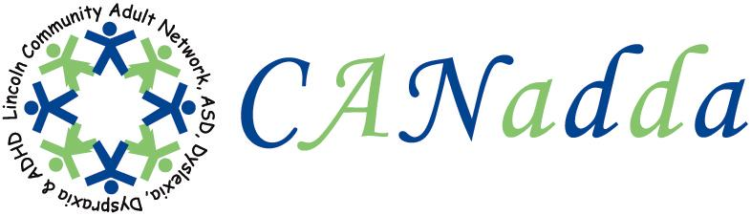
Newsletter May 2010 Issue 9

Tel: 01522 880922

Web Site: www.canadda.org.uk

Chairperson Mrs Debbie Marshall Email debbie.canadda@yahoo.co.uk

Chair of CANadda

Debbie Marshall

At CANadda’s games and socialising evening last month, there was a nice surprise, Carol Daman-Willems turned up. Carol is the PCSO for the area. She wants to take an interest and be involved in the group, she will be dropping in at times. She will be coming in on Monday 20th September to give a talk on Personal Safety. I also had a nice surprise when Christine King turned up as well. Christine is the Washingborough Methodist Church Minster and will also be taking an interest in the group.

I would like to officially welcome Sheena Giff to the committee. She has taken on the volunteer role of Assistant Secretary and will be looking after the ADHD side. Jo Minchin will be looking after the Dyslexia side.

If you are not all ready aware, CANadda has moved to the Heighington Methodist Church whilst the Washingborough Methodist Church undergoes redevelopment. CANadda will be moving back once the work has finished. Please note the change of address for support meetings, until further notice.

CANadda is looking forward to Carol Reding, Direct Payments Development & Coordination Officer from Lincolnshire County Council, coming on Monday 17th May to give a talk on Direct Payments. The support meeting is planned to start at 7:30.

Support Meeting Dates

17th May – Direct Payments
21st June – OCD and Dyslexia
19th July – Anger Management
16th August – Games and Socialising for
families (any age)
20th September – AGM Meeting &
Personal Saftey /
Open Discussion

Heighington Methodist Church
Mill Lane off Station Road, Heighington, LN4 1QJ

7:30pm – 9:30pm

Car Park is in
St Thomas Church / Heritage Rooms.

30p for refreshments

Coastal Carers Fun Day

FREE EVENT

Saturday 19 June 10am – 3pm

Stanley Avenue, Mablethorpe

Jammed packed with fun and activities all day. For more information, contact:

Debbie Prince 01507 329567
Email: debbie.prince@e-lindsey.gov.uk.

Girls Night Out

CANadda is having a girls’ night out on Monday 10th May. We are going to meet at the Pride of Lincoln for a meal and drinks. We are meeting at 8pm. If you are interested in joining us, please let me know, Debbie Marshall.

All ladies are welcome.

Bowling

Bowling has been booked at Washingborough for Thursday 3rd June 2010. We are having one game at 7:30pm. The price is £2.20 per game. We are having food first, so we will be meeting at 6:30pm. After bowling, we will be staying for drinks, anyone welcome. If you are interested, please email me.
A Special Thank You To

David Harris, for his kind donation.

Quotes

“I hated to read… What a normal kid could read once and understand, I had to read three or four times… I learned that through hard work I could overcome my handicap.”

Neil Bush, son of Barbara and George Bush.

“I was expelled from four schools. Today I still read with difficulty.”

Sarah Miles: Actress, author and playwright.

Dyslexia

Dyslexia is a hidden disability that mainly affects the development of literacy skill such as reading, writing and spelling. In the UK 10% of the population is affected, to varying degrees – 4% has severe dyslexia. It can affect anyone, no matter how intelligent.

Some people with dyslexia show strengths in creative abilities, problem solving, visual and technical skills.

Dyslexia Action

Telephone: 01522 539267
Website:www.dyslexiaaction.org.uk
Email: info@dyslexiaaction.org.uk

CANadda’s Library

We have some more new books in our library. A full list can be found on the forum on our website.


Lincolnshire Autism Awareness Rally

20th –23rd August 2010

Opposite Butlins, Skegness, Weekend Camping and Day Passes
Help & Support Autistic Children & Their Families

Children FREE

There will be speakers, information stands and workshops are planned. Activities including arts and crafts, fun fair for the young and children plus much more.

For Details Email: ingalllynn@yahoo.com Tel: 07904941389
MIXIT Stageschool

This is for adults and children 8+ with a disability. Interested? To find out more:
Ring 01207 232727 or 07532 008120
Web site www.mixitmusic.co.uk
Email Joannebekis@yahoo.com
All sessions can be paid for using a Direct Payment or an Individual Budget.

CANadda Support Meeting

DIRECT PAYMENTS
17th May 2010

Carol Reding – Direct Payments Development & Coordination Officer
will be giving a talk and Geoff Garner hopes to give a talk on personal finance.
Everyone is welcome.

