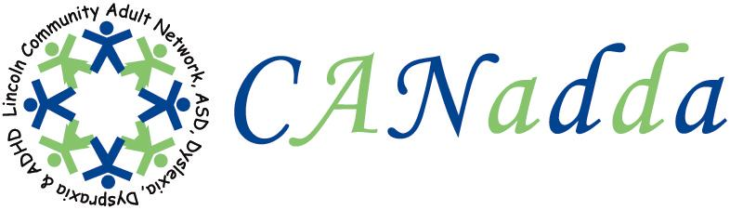
Newsletter September 2010 Issue 13

Tel: 01522 880922

Web Site: www.canadda.org.uk

Chairperson Mrs Debbie Marshall Email debbie.canadda@yahoo.co.uk

Chair of CANadda

Debbie Marshall

CANadda had its busiest month so far, with lots going on. CANadda’s support evening on 16th August went down well and was a good giggle. I want to know where our summer has gone.

CANadda had its first birthday with a joint launch of CANadda’s two new leaflets and poster. Our posters and leaflets so far have gone out to libraries, GPs, hospitals and the Co-Operative pharmacies all over Lincolnshire.

Debbie Marshall and Phil Culmer attended the Autism Rally on Saturday 21st to Sunday 22nd. Even with the bad weather we survived and we both had a good time.

You can find out more on the birthday/launch and the Autism Rally, including pictures, on CANadda’s website. If you haven’t been on CANadda’s website for a while, it is growing all the time, thanks to Mark Iley who has done a marvellous job.
Phil Culmer has set up a blog, which can be found on www.canadda.org.uk/wordpress. Phil will be maintaining this.

Don’t forget our next support meeting, which is on Monday 20th September. This is our first AGM meeting and Caroline Daman-Willems, our local PCSO, will be there, giving a talk on personal safety.


Support Meeting Dates

20th September – AGM Meeting &
Personal Safety /
Open Discussion.
18th October – Emotional Support / Open
Discussion – Faye Johnson.
15th November – Hate Crime – Melanie
Cowell from Lincs Police.
20th December – Christmas Party.
18th January 2011 – Strut and Service
offered – Eugenia Pryor.

Heighington Methodist Church
Mill Lane off Station Road, Heighington, LN4 1QJ

7:30pm – 9:30pm

Car Park is in
St Thomas Church / Heritage Rooms.

Refreshments available (small charge)

Social Events For Your Diary

22nd September – Bowling at
Washingborough, 11:30am.
20th December- Christmas Party, +
raffle, 7:30pm.

Zoe Creasly
Event Coordinator

A Special Thank You To

David Harris, for his kind donation.

Also, to the following, for raffle prizes donated: Rand Farm Park (family ticket); Terrain Services (which offer off road driving activities for individuals and groups and also training courses for work that require professional training); The Kensington Salon (back massage); Laser Quest; Doddington Hall & Gardens (family ticket); ELK Racing (Go-Karting); and Rachel Davies.

12th Annual Lincoln
Autism Conference

Thursday 4th November 2010

Branston Hall Hotel
Lincoln
LN4 1PD

BOWLING

Bowling has been booked at Washingborough for Wednesday 22nd September starting at 11:30am for two games at £2.20 per game. Afterwards, you may like to stay on for lunch. To book your place, payment is to be made in advance.

Autism Spectrum Disorder (ASD)

ASD varies from person to person. Fundamentally it means that there is a weakness of understanding in the following areas:

- Social Communication
- Social Interaction
- Social Imagination.

It is estimated that over 500,000 people in the UK have Autism or Asperger Syndrome.
Famous Dyslexia Quotes

Magic Johnson, Professional basketball player. “The looks, the stares, the giggles… I wanted to show everybody that I could do better and also that I could read.”

Harry Anderson, actor, magician, comedian. “In my early school years, when large pictures accompanied schoolbook texts, I was called ‘brilliant’ by my teachers. Later when my reading started to slow down, I was afraid of losing my title, so I manipulated it. I did everything but tell people I had trouble reading.”

Shop Online and Raise Funds

If you shop online anyway, then why not raise valuable extra funds for us by using this fantastic scheme. All you need to do is visit www.easyfundraising.org.uk/canadda and when you register, select CANadda as the organisation you wish to support. It is  completely FREE to register.

ADHD

ADHD Awareness Week
19th – 25th September 2010

Work Related Stress
How to tackle work related Stress
www.hse.gov.uk

Three ADHD Articles
- Pre-Natal Links to ADHD - If you or someone you know is pregnant or plans to become pregnant, find out the pre-natal links to ADHD and minimise the risks.
- Tobacco and Lead Exposure in ADHD - Lead and tobacco exposure each can harm a foetus and increase the risk of ADHD. But together, this risk skyrockets.
- Using Neurofeedback to Treat ADHD - Results of previous neurofeedback studies on ADHD have been mixed. But a new one shows it is a very effective treatment for ADHD.

Dial a Ride 

The transport service telephone:- 01522 544983 or visit, http://www.lincolnshire.gov.uk/section.asp?catId=6583
The Bus Station, Melville Street, Lincoln.

CANadda Support Meeting

AGM Meeting & Personal Safety
Caroline Daman-Willems (PCSO)
20th September 2010

It’s CANadda 1st AGM Meeting. We also have Caroline Daman-Willems who is a PCSO for the area coming along to give a talk on Personal Safety. If there is any time left over there will be an opportunity for an open discussion.

Everyone is welcome.

This is not counselling or any form of therapy.

X Factor Karaoke 
Chris Tooke in association with the
Lincolnshire Autistic Society.
Friday 29th October, at 7pm.
St Norberts Church Hall,
St Thomas’s Road, Spalding.
For further information and tickets contact Lesley (Autism Care) on 01526 320312.

DYSPRAXIA
Dyspraxia Awareness Week
10th – 17th October 2010.
ANTI BULLING
Anti Bulling Week
15th – 19th November 2010.
Theme: Taking Action Together.
It has been announced that the government will cut funding to train teaching assistants. http://gu.com/p/2tp2y/tw

Dyslexia Action

