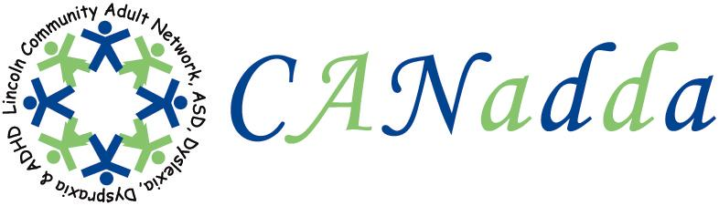
Newsletter October 2010 Issue 14

Tel: 01522 880922

Web Site: www.canadda.org.uk

Chairperson Mrs Debbie Marshall Email debbie.canadda@yahoo.co.uk

Chair of CANadda

Debbie Marshall m

Autumn feels well and truly here now and I don’t like the winter months. CANadda had its first AGM on Monday the 20th of September. If you missed it, you will be pleased to know that everyone got nominated back in. Caroline Daman-Willems PCSO came with a policeman and they gave a talk on Personal Safety. Afterwards, they gave out a free personal alarm to everyone. Caroline would like to come back next year and give a talk on how to keep safe when using the Internet.

Bowling on 22nd September was a success; it ended up being all girls. We had two games and I do apologise to the other players as I won both games as I was on top form. I know the others that attended were not impressed when I threw the ball and I hurt my thumb and then ended up getting a strike. I don’t know what Zoe was doing, but she broke the machine twice. After we finished playing, we sat down and enjoyed the food and conversation.

CANadda was at Tesco on 26th September as Tesco had a Community Fair. Zoe Creasey and I attended; we had a really lovely day. Tesco put on a superb day laying on free food, drink and giving out freebies. It gave me an opportunity to raise some money for CANadda. This was CANadda’s first general public event and I wasn’t sure how we would be received. I am pleased to announce we got a really good response and the general public wanted to support us and we were well received. I even had some bullying campaign posters up and they got a good reception from the public too. 

Bullying can be concerning for children and their parents. It can have a significant effect on a child’s education and emotional well-being. If you are concerned that your child is being bullied in school, the following web site may be helpful:

http://www.lincolnshire.gov.uk/section.asp?docid=30053&catid=14906

At our support meeting on 18th October, Faye Johnson is coming along to have a chat about what sort of Emotional Support you might like to receive in the future. Judith Alloway Carers Lead – Health Partnership is also coming to do a talk on what services Carers are looking for.

Please note CANadda will be back at the Washingborough Methodist Church as from the 18th October 2010.



Support Meeting Dates

18th October – Emotional Support / Open
Discussion – Faye Johnson & Judith Alloway
Carers Lead-Health Partnership.
15th November – Hate Crime – Melanie
Cowell from Lincs Police.
20th December – Christmas Party.
17th January 2011 – Strut and Service
offered – Eugenia Pryor.

Washingborough Methodist Church
Lincoln Rd, Washingborough,

LN4 1AT

7:30pm – 9:30pm

Refreshments available (small charge)

Social Events For Your Diary

20th December- Christmas Party, +
Raffle, 7:30pm.


Zoe Creasey
Event Coordinator

12th Annual Lincoln
Autism Conference

Thursday 4th November 2010

Branston Hall Hotel, Lincoln
9:15am – 3pm

Carol Bentley
Carol.bentley@ulh.nhs.uk

A Special Thank You To

David Harris, for his kind donation.

Also, Sheena, Zoe and myself who donated prizes for the tombola that we did to raise funds for CANadda


Dyspraxia

Dyspraxia may also be known as clumsiness. It is generally recognised to be an immaturity or impairment of the planning and organisation of movement and co-ordination. It affects the following areas:

- Gross & Fine Motor Skills
- Perception & Thought
- Speech & Language

Up to 6% of the UK population is thought to be affected, with up to 2% severely.
Famous Dyspraxia Quote

“In theory I’m naked underneath.” “I think I’m highly normal. I’m attending school after acting, I’m going out with friends, going to the cinema – I’m just doing everything a normal teenager does. People think I can’t leave the house without being in a crowd of fans – but that’s not true. I’m able to do more things than people might think.”
Daniel Radcliffe - Actor (Harry Potter)


CANadda’s Web Site

Please don’t forget to view CANadda’s web site and check out the blog which is updated regularly. www.canadda.org.uk

DYSPRAXIA
Dyspraxia Awareness Week
10th – 17th October 2010.
Work Related Stress

How to tackle work related Stress
www.hse.gov.uk

ANTI BULLYING Week
15th – 19th November 2010.

Theme: Taking Action Together.

. Teachers shy away from
Hyperactivity and Autism.

Brian Lamb, chair of the special educational consortium, said “Teachers are concerned about disruptive behaviour in the classroom. There’s the fear that certain pupils will be unmanageable. With physical disabilities, as long as you’ve solved the basic access issue, there’s no other problem.”

“But for all children, you have to have the right resources, or they can become as isolated in the mainstream as in special schools.”

For the full article click on the below link.

http://www.tes.co.uk/article.aspx?storycode=2145418

CANadda Support Meeting
Washingborough Church Hall

Emotional Support / Open Discussion and
Support Services for Carers
18th October 2010

Judith Alloway Carers Lead – Health Partnership is coming to find out what support carers are looking for and Faye Johnson is also coming to find out what sort of Emotional Support adults would be looking for in the future.

Everyone is welcome.

This is not counselling or any form of therapy.

X Factor Karaoke

Chris Tooke in
association with the
Lincolnshire Autistic Society.
Friday 29th October, at 7pm.
St Norberts Church Hall,
St Thomas’s Road, Spalding.
For further information and tickets contact
Lesley (Autism Care)
on 01526 320312.
It has been announced that the government will cut funding to train teaching assistants. http://gu.com/p/2tp2y/tw

Dyslexia Action

